Experiment 7
Operational Amplifier

Introduction
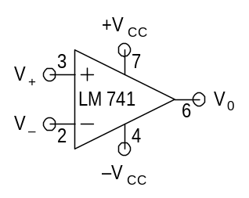
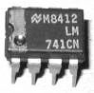
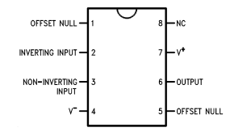
The operational amplifier (abbreviated as op-amp) denoted by the number 741 as shown in Fig.1 (schematic), Fig. 2 (actual chip), and Fig. 3 (pin numbers), is among the most basic linear integrated circuits frequently employed in diverse low frequency applications. The actual chip has four pins on each side, with a dot (or an indent) just above pin no.1 (Fig.2).
Fig. 1
Fig. 2
Fig. 3
Referring to Figs. 1 and 3, the op-amp has two inputs, viz., inverting (V⁻: pin no. 2) and non-inverting (V⁺: pin no. 3), and one output (V₀: pin no. 6). Pin numbers 7 and 4 are used for the power supplies (+V_{CC} and −V_{CC} respectively). Pin numbers 1 and 5 will not be used in this experiment (keep them open). The input-output relationship of an op-amp is given by V_{o} = A(V⁺ − V⁻), where the differentia1 voltage gain A is very large. For an ideal opamp: (i) A is infinite, (ii) the input impedance is infinite, and (iii) the output impedance is zero, making it practically an ideal controlled voltage source. However, in a practical op-amp, A is typically in the range of 10⁴ to 10⁶ over the frequency range of interest and for different IC types.

CARE
- Connect the op-amp such that its pin 1 is on your left side, as shown in Fig. 2.
- Be doubly sure that the +12 V (pin 7) and –12 V (pin 4) supplies are connected properly to the op-amp. If you interchange these connections or connect them to some other pins, the op-amp will get damaged instantly. This is the most common reason for op-amp damage.
- Make sure to turn the power supply on after all the connections are made, and turn it off after the measurements are done.
- It is a good practice to keep the DSO and FG in ON condition. Connect the FG output to the left side of the breadboard and use a jumper to connect it to your circuit as required. Note that the FG signal should appear at the op-amp circuit input only after the opamp receives DC power.
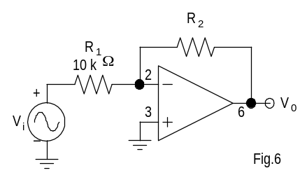
Fig. 4
1. Inverting Amplifier
- Wire the circuit of Fig. 4. Choose R₂ = 51 kΩ. Adjust the FG output to produce V_{i} = 0.1 sin(ωt) (f = 1 kHz).
- Observe and sketch the V_{i} and V₀ waveforms.
- Measure the voltage gain A_{v} ≡ V₀/V_{i}. What is its sign?

2. Non-Inverting Amplifier
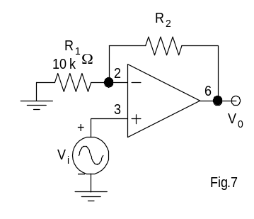
- Wire the circuit of Fig. 5. Choose R₂ = 51 kΩ. Adjust the FG output to produce V_{i} = 0.1 sin(ωt) (f = 1 kHz).
Fig. 5
- Observe and sketch V_{i} and V₀ waveforms.
- Measure the voltage gain.

3. Difference Amplifier (DA)
The aim of this part of the experiment is to study the performance of a DA by measuring its common-mode and differential-mode gains. In an ideal DA, the differential-mode gain A_{d} is infinite and the common-mode gain A_{c} is zero, thus giving an infinite common-mode rejection ratio (CMRR ≡ |A_{d}/A_{c}|). However, in a practical op-amp circuit, since A_{d} is finite and A_{c} is not exactly zero (but quite small), the CMRR might be of the order of 10⁴. The circuit of Fig. 6 will work as a DA when R₂/R₁ = 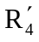/R₃ (where = R₄ + part of the 10 kΩ potentiometer (R) that is not shunted), giving a voltage gain of R₂/R₁.

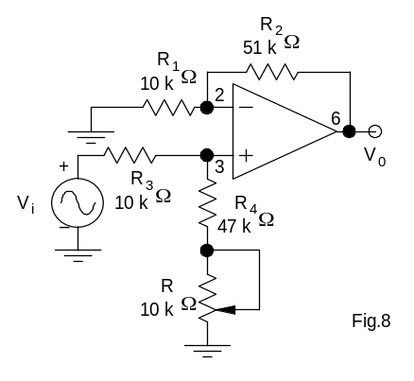
A. Measurement of the Common-Mode Gain A_{c}
Fig. 6
- Wire the circuit of Fig. 6, but instead of grounding one end of R₁, apply V_{i} to both R₁ and R₃. Adjust the FG output to produce V_{i} = 10 sin(ωt) (f = 1 kHz).
- Observe the output voltage V₀ on the CRO and minimize its amplitude by adjusting the 10 kΩ potentiometer. (Perform this step as best as you can. As V_{o} decreases with the potentiometer adjustment, increase the sensitivity of the CRO channel and obtain the very minimum possible V_{o}). Keep this setting of the potentiometer unchanged for the next part of the experiment.
- Calculate A_{c} ≡ (V_{o}/V_{i}) _{common-mode}

B. Measurement of the Differential-Mode Gain A_{d}
- Remove the input V_{i} from one end of R₁ and connect that end to ground, i.e., the connection of the circuit now should look exactly as given in Fig. 6. Adjust the FG output to give V_{i} = 0.5 sin(ωt) (f = 1 kHz). Observe the output voltage V_{o} on the CRO.
- Calculate A_{d} ≡ (V_{o}/V_{i}) _{differential-mode}
- Calculate CMRR ≡ |A_{d}/A_{c}|.

4. Schmitt Trigger (Regenerative Comparator)

Schmitt trigger circuits are also used extensively in wave shaping. The positive feedback in the circuit ensures that the output will be either at +V_{sat} or at –V_{sat}. This is especially useful when the input signal is slowly rising or falling. The hysteresis seen in its transfer characteristics (Fig. 7) finds use in many practical applications.
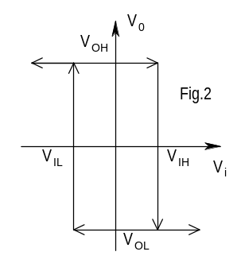
- Wire the circuit of Fig. 8. Adjust the FG output to produce V_{i} = 8 sin(ωt) (f = 1 kHz). Connect V_{i} to CH-1 ( X ) and V_{O} to CH-2 ( Y ) of the DSO, and observe the V_{O} versus V_{i} characteristics in the XY mode.
Fig. 9
Fig. 7
- Vary the 10 kΩ potentiometer from one extreme to the other and observe the changes in the response.
- For the two extreme positions of the potentiometer, observe and sketch the V_{o} versus V_{i} characteristics. (DSO in X-Y mode)
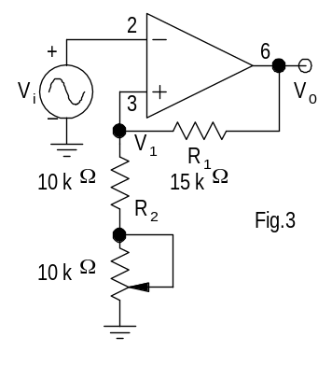
- From these characteristics, determine V_{OH}, V_{OL}, V_{IH}, and V_{IL} for the two cases.
Fig. 10
Fig. 8

